CSE-326

FINAL REPORT

PROJECT TITLE: RESTAURANT

SUBMITTED TO: SUKHVIR KAUR

SUBMITTED BY: SHREYA[11900811]

A.BALAJI[11903167]

SECTION:KI9SJ

INTRODUCTION

"ROYAL PLATE" is a web site. This system is developed to automate day to day activity of a restaurant. Restaurant is a kind of business that serves people all over world with ready made food. This system is developed to provide service facility to restaurant and also to the customer. This restaurant management system can be used by employees in a restaurant to handle the clients, their orders and can help them easily find free tables or place orders. The services that are provided is food ordering and reservation table management by the customer through the system online, customer information management and waiter information management, menu information management and report. The restaurant menu is organized by categories (appetizers, soups, salads, entrees, sides and drinks) of menu items. Main objective build the system this is to provide ordering and reservation service by online to the customer. Each menu item has a name, price and associated recipe. A recipe for a menu item has a chef, preparation instruction sand associated ingredients. With this system online, ordering and reservation management will become easier and systematic to replace traditional system where are still using paper. To resister a meal online, the customer has to become a member first then he can access the later part of the site. this project to facilitate customer for make online ordering and reservation. The option of becoming member was only an attempt to avoid (to some extent) placing the fake bookings.  
  
Royal plate is the system for manage the restaurant business. After successful login the customer can access the menu page with the items listed according to the desired time. The main point of developing this system is to help restaurant administrator manage the restaurant business and help customer for online ordering and reserve table. In proposed system user can search for a menu according to his choice i.e. according to price range and category of food and later he can order a meal.  
  
The project is developing because; many restaurants have a lot difficult to manage the business such as customer ordering and reservation table. If the customer book an order and later wants to cancel the order, he is permitted to do this only within a specific time period. By using manual customer ordering is difficult to waiter keep the correct customer information and maybe loss the customer information. The customer is also given with the facility to view the status of the order and if the order is ready then he can go and get it.  
  
So, Royal plate will develop to help the restaurant administrator to manage restaurant management and for customer make their online ordering and reservation table. At Management side, initially the staff member has to login, and according to his designation the privileges are set. Other than that, this project is to upgrade the manual system and make the business easily to access and systematic. If the staff member is a cook, then he is allowed to edit only the order items status, indicating which menu items he has prepared

FLOW CHART OF WEBSITE

CONTACTUS

OUR STORY

SINCE 1971

S

DISHES

DOES/DONTSS

PICTIURES

ROYAL PLATE

DESCRIPTION

1.HOME PAGE-In this page connections to other pages are made using links .As in this homepage buttons like HOME,ABOUT,MENU,GALLERY,HEALTHY TIPS and CONTACT US are linked to the respective pages providing particular information related to the pressed link.

In HTML we use css in head section to style the website. There are three types of css Inline, Internal, External “CSS. In this project we have used internal “CSS” to style our website in head section. In this part we have used table tag, paragraph tag, anchor tag and div tags to style our website.

2.BACKGROUND IMAGE-This image is used at the top of a homepage. It is the image of a restaurant . In this we have used img tag for background image. This image describes about the restaurant “ROYAL PLATE”.

Using this feedback option people will be provided with an option to rate their experience in the restaurant.

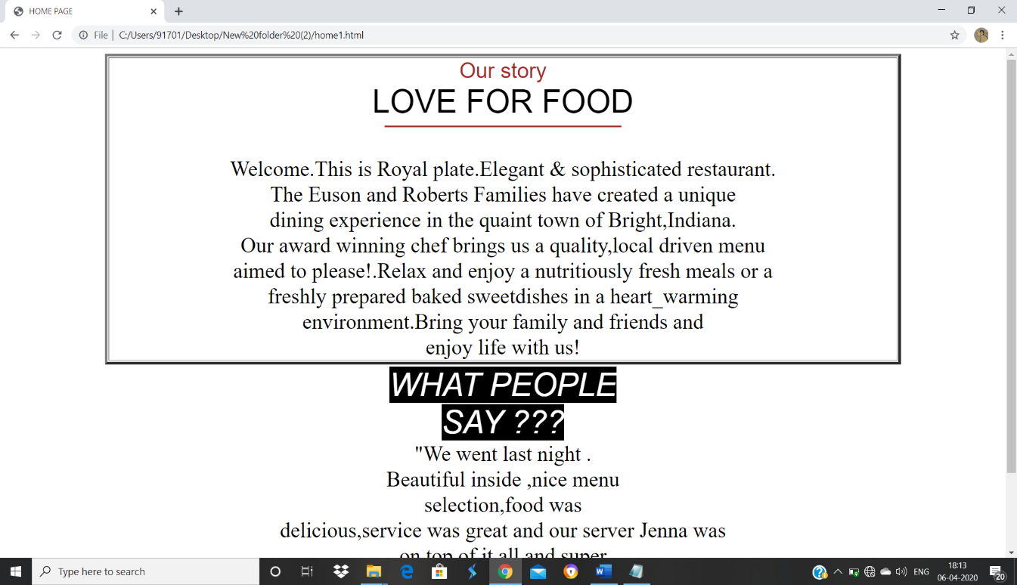

3.ABOUT PAGE

In this page we have details about “ROYAL PLATE”. Details like when it was started and its motives. In this section we have use div tag img tag paragraph tag to describe the information about restaurant and anchor tag to link website.

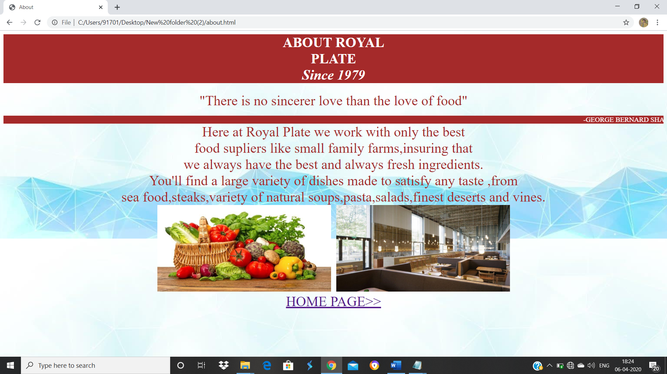

4.MENU PAGE:

This page gives the detailed information about many type of delicious food and recipes available to the coustemer .In this page we mostly used internal css in head section. Table tag for the information about recipes and food available in the restaurant.

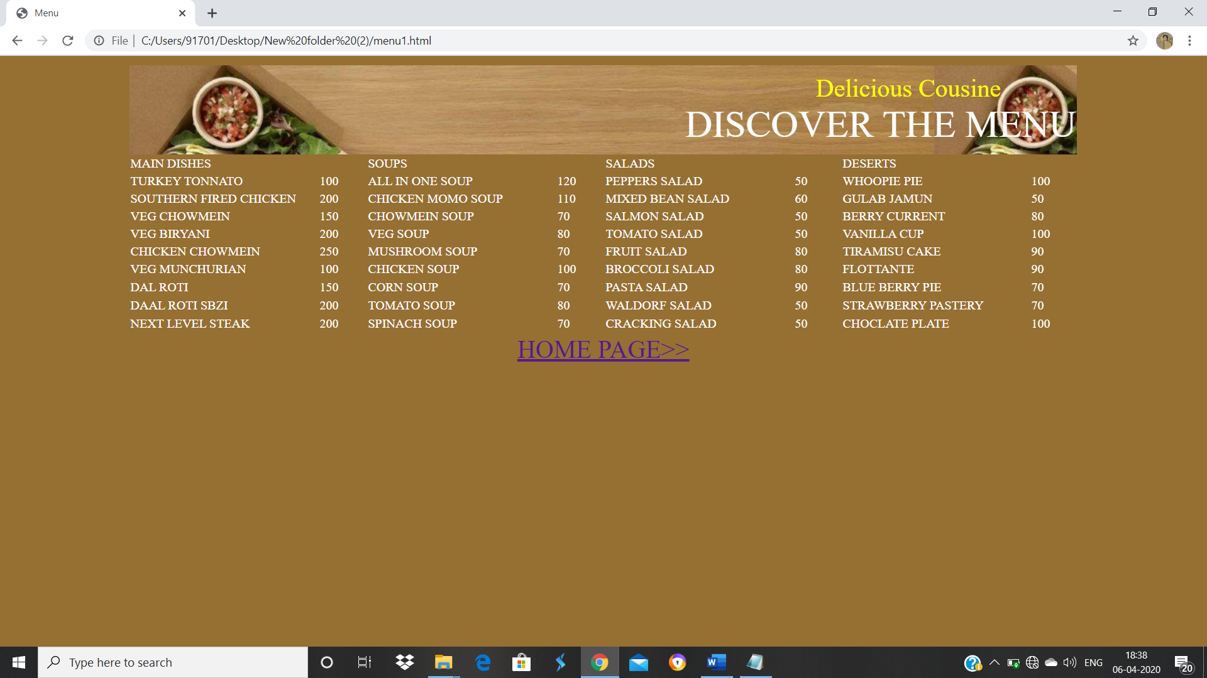

5.GALLERY PAGE:

This section of webpage we have a look on the pictures of restaurant for the coustmer who visit the website .In this section we have used internal css and div tag and img tag for gallery page.

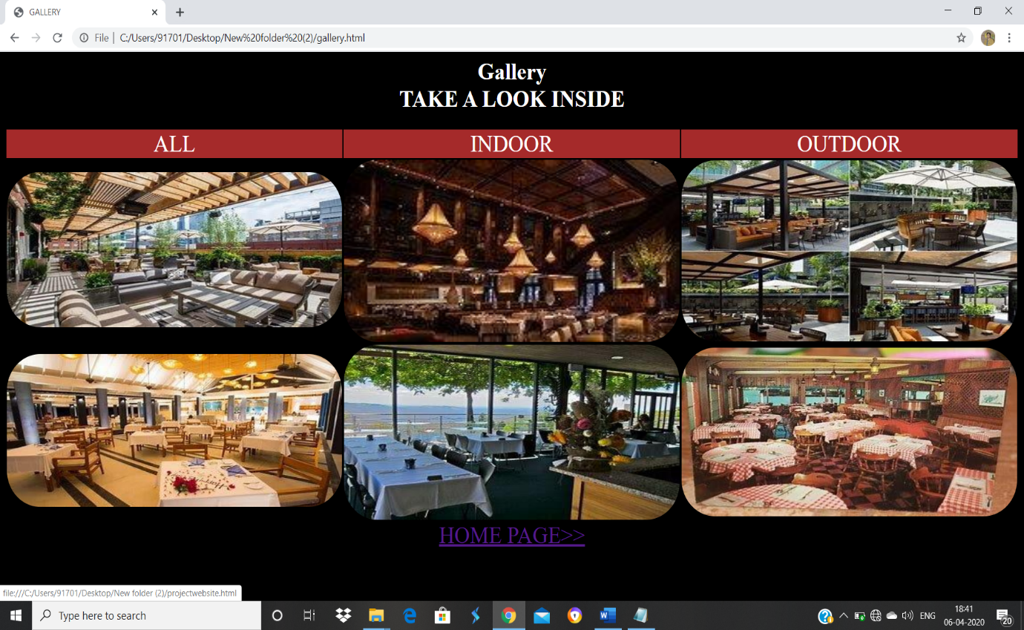

6.HEALTHTIPS PAGE:

This page gives us information about healthtips and does and donts while eating food .

In this section of page we have used “LIST TAGS” like ordered and unordered and anchor tag to link web site.

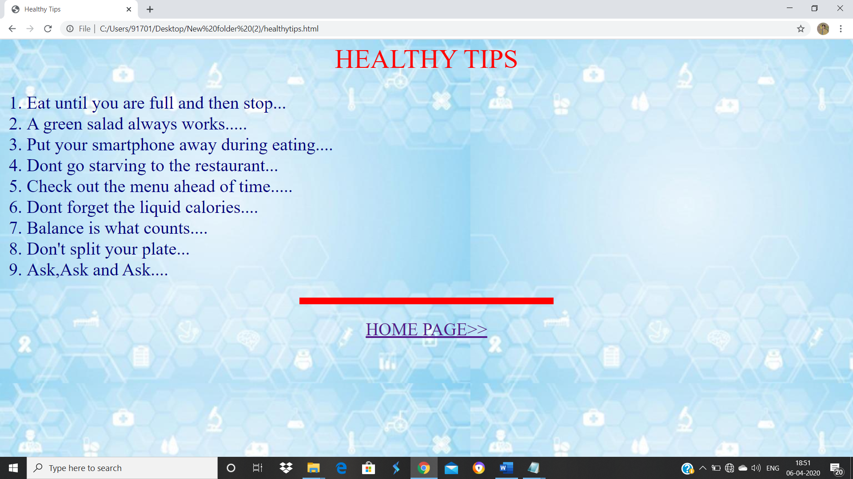

7.CONTACT US PAGE:

This page gives us information about contact details like phone no, location of the restaurant. In this section of page we have used internal css table tag, anchor tag, font tag to designe website.

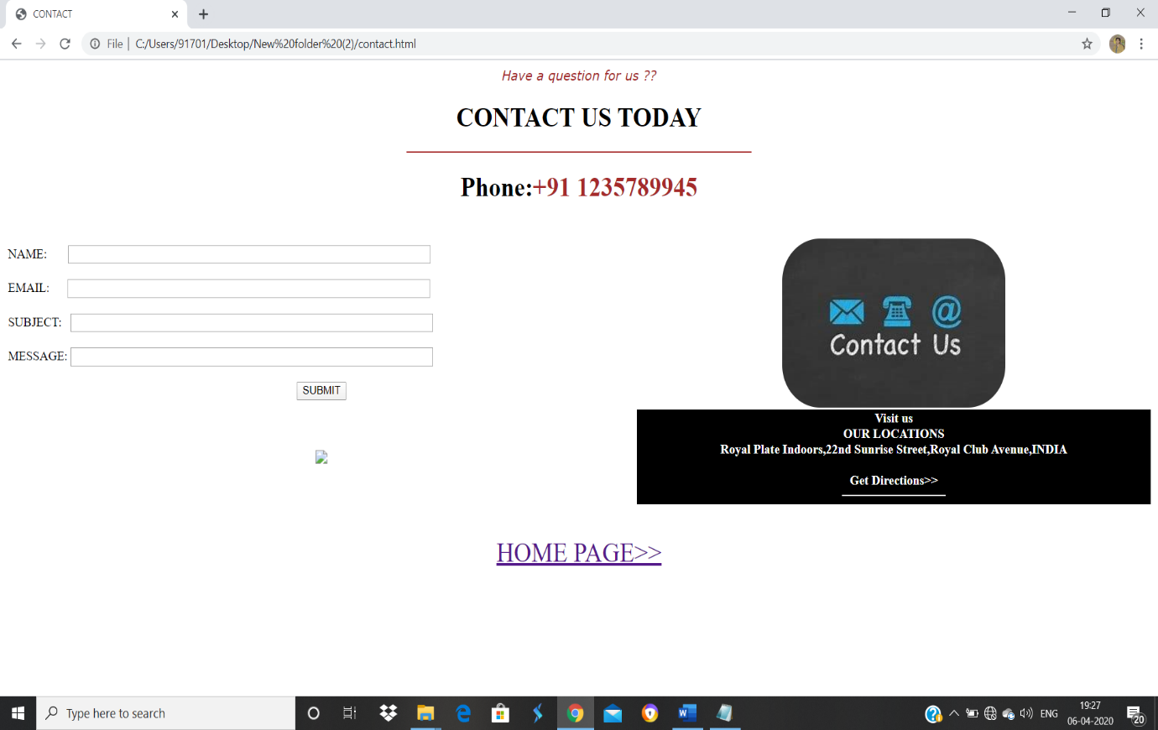

MODULE

1.HOMEPAGE :

The home page is done by Balaji. This section is done by using using HTML and css and a little of javascript.

2.ABOUT PAGE:

This page is done by Shreya , this page explains all about the restaurant. This is done by using HTML and CSS.

3.MENU PAGE:

This page is done by Shreya, this page explains all about the spicy and delicious food served by the restaurant. This is done by using HTML and CSS.

4.GALLERY:

This page is done by Balaji, this page have the image of restaurant. This is done by using HTML and CSS.

5.Healthtips:

This page is done by Shreya, this page explains about does and donts while eating food. This is done by using HTML and CSS.

6.CONTACT US:

This page is done by Balaji, this page have the information regarding restaurant. This is done by using HTML and CSS.

Video: <https://www.youtube.com/watch?v=Jk2CDLMCRq4&feature=youtu.be>

WEBSITE IMAGE

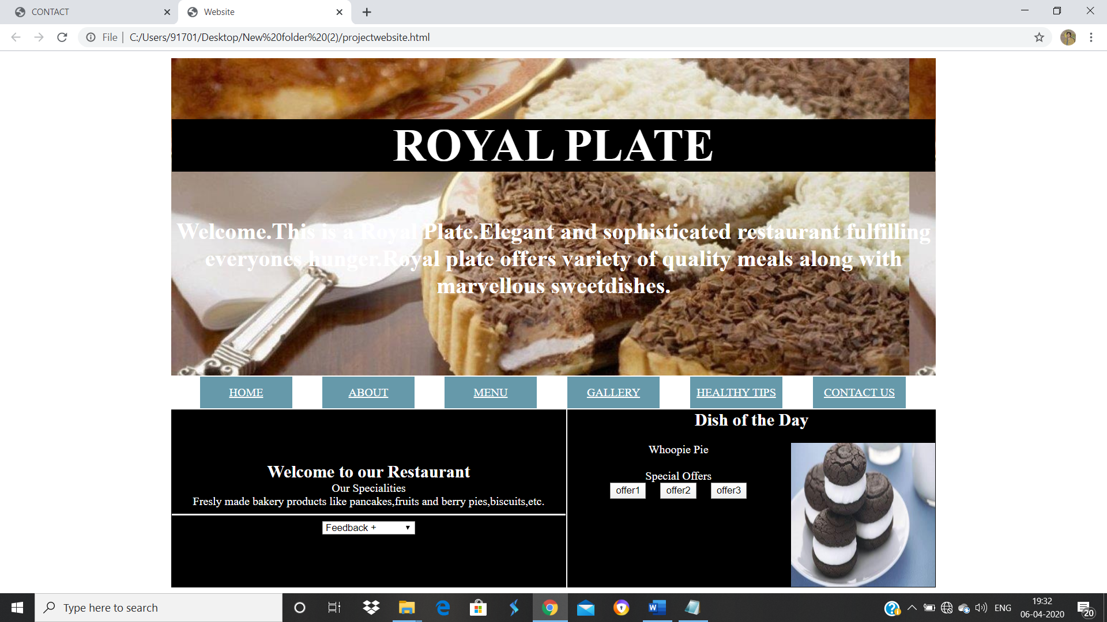

CONCLUSION:

This project is based on a webpage designing is really knowledgeable project. HTML has been used in this project to create a website based on restaurant.We have learned how to create structured and functional HTML documents-everything builts on this.To conclude with this project helps in advertising a restaurant by creating a restaurant website using HTML.Under which various types of tags are used to make the website attractive and eyecatchy while displaying all the important information about restaurant.